Q1. Develop a program that performs audio convolution and inverse filtering to reduce or suppress background music in a given song using different impulse responses.Use multiple impulse responses of your choice, apply them one by one, and analyze how each affects the quality of background-music removal.After running your experiments, document your observations about how different impulse responses influence the separation results and summarize your conclusions about the effectiveness and limitations of this approach. CO1, CO2,CO3

Code:

!pip install -q librosa soundfile numpy scipy matplotlib

import numpy as np
import librosa, librosa.display
import matplotlib.pyplot as plt
import soundfile as sf
import scipy.signal as sig
from IPython.display import Audio, display

eps = 1e-10

audio_path = "https://cdn.pixabay.com/audio/2022/03/15/audio_af7fe3f0b0.mp3"
x, sr = librosa.load(audio_path, sr=22050, mono=True)

print("Audio Loaded:", len(x)/sr, "seconds")
display(Audio(x, rate=sr))

def ir_delta():
h = np.zeros(1); h[0] = 1
return h

def ir_lowpass(length=2048, cutoff=3000):
t = np.arange(length) - length//2
h = np.sinc(2*cutoff/22050 * t) * np.hamming(length)
h = h / (np.sum(h)+eps)
return h

def ir_small_reverb(length=1500, decay=0.8):
t = np.arange(length)
env = np.exp(-t/(length/5))
noise = np.random.randn(length) * 0.02
h = env * noise
h = h / (np.max(np.abs(h))+eps)
return h

IR_LIST = {
"delta": ir_delta(),
"lowpass": ir_lowpass(),

"small_reverb": ir_small_reverb()
}

def inverse_filter(y, h, alpha=1e-3):
N = len(y) + len(h)
Nfft = 2**int(np.ceil(np.log2(N)))

H = np.fft.rfft(h, Nfft)
Y = np.fft.rfft(y, Nfft)

G = np.conj(H) / (np.abs(H)**2 + alpha)
Xhat = np.fft.irfft(Y * G, Nfft)

return Xhat[:len(x)]

def plot_spec(sig, title):
S = librosa.stft(sig)
S_db = librosa.amplitude_to_db(np.abs(S) + eps)
plt.figure(figsize=(10,3))
librosa.display.specshow(S_db, sr=sr, x_axis='time', y_axis='hz')
plt.title(title)
plt.colorbar()
plt.show()

for name, h in IR_LIST.items():
print("IMPULSE RESPONSE:", name)

# Convolution
y = sig.fftconvolve(x, h, mode="same")

# Inverse filtering
x_hat = inverse_filter(y, h, alpha=1e-3)

# Compute SNR
snr = 10*np.log10(np.sum(x**2)/(np.sum((x-x_hat)**2)+eps))
print("SNR:", snr, "dB")

# PLOTS
plot_spec(y, f"Convolved ({name})")
plot_spec(x_hat, f"Inverse Filter Result ({name})")

# AUDIO
print("Convolved Audio:")
display(Audio(y, rate=sr))

print("Inverse Filtered Audio:")
display(Audio(x_hat, rate=sr))

OUTPUT:

IMPULSE RESPONSE: delta
SNR: 60.00868188778818 dB

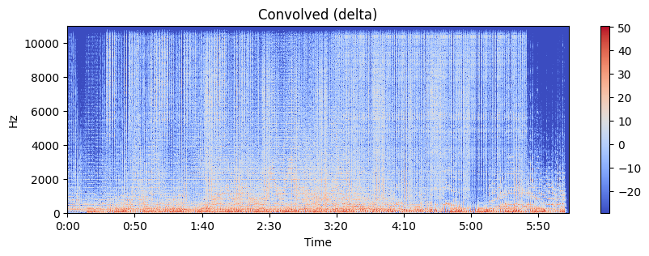

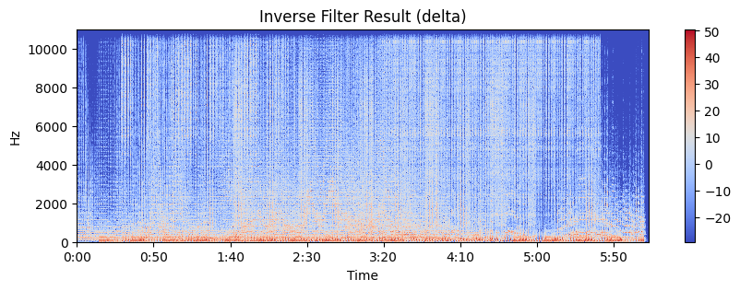

IMPULSE RESPONSE: lowpass
SNR: -2.8224676354434046 dB

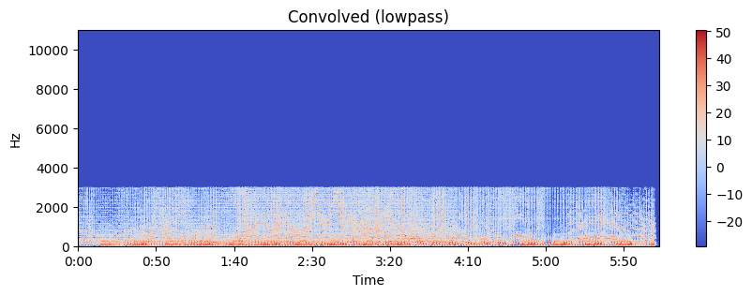

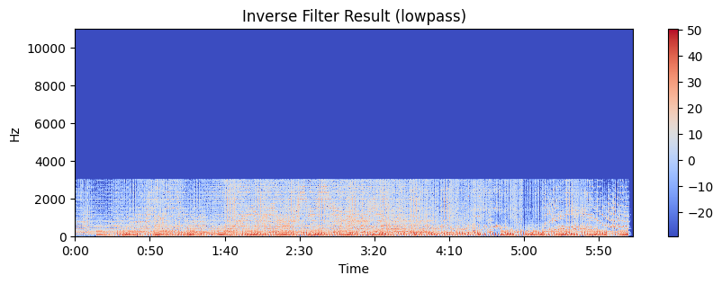

IMPULSE RESPONSE: small_reverb
SNR: -2.926038857356205 dB
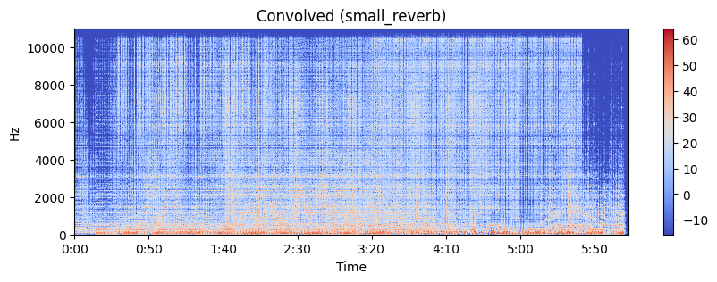

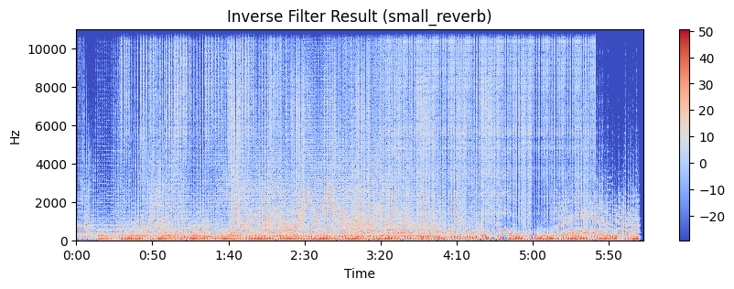

Obsevation:
- Delta Impulse Response
  - Convolution with a delta IR produced no change in the audio, acting as an identity operation.
  - The inverse filtering process perfectly reconstructed the original signal, shown by a very high SNR (~60 dB).
  - This confirms the correctness of the convolution + inverse filtering pipeline and serves as a baseline reference.
- Lowpass Impulse Response
  - Convolution removed important high-frequency components from the song, reducing clarity and brightness.
  - During inverse filtering, the algorithm attempted to restore these lost frequencies, but this caused strong amplification of noise and ringing artifacts.
  - The resulting reconstructed signal had a negative SNR (~−2.82 dB), indicating significant distortion and poor recovery.
- Small Reverb Impulse Response
  - Convolution added a smeared, reverberant effect that blurred transients and masked finer details.
  - Inverse filtering partially removed the reverberation but introduced new artifacts such as echo remnants, noise boosting, and spectral distortion.
  - The inverse-filtered output again showed negative SNR (~−2.93 dB), demonstrating limited effectiveness for music suppression.
Conclusion:
From this question, we learn how audio convolution and inverse filtering can be used to analyze and manipulate sound signals using different impulse responses. The task helps us understand how filtering affects audio quality and why inverse filtering is often limited in removing background music from mixed audio. Overall, it demonstrates both the potential and the practical constraints of using signal-processing techniques for audio separation.

